Full Stack Development with MERN
Project Documentation format
1. Introduction
• Project Title: Vehicle Insurance Management
• Team Members: S. Devi sri prasad – Servicenow Developer
2. Project Overview
• Purpose: To digitize and automate the end-to-end vehicle insurance lifecycle — registration, policy management, claim submission, fraud detection, and notifications — using ServiceNow’s cloud platform.
Features:
- User registration & login via ServiceNow portal
- Policy creation, renewal, cancellation workflows
- Claim submission with document upload
- Fraud detection using ML model integration
- Admin dashboard for approvals & analytics
- Notifications via email/SMS through ServiceNow Notification Service

3. Architecture
Frontend: ServiceNow UI Builder for web portal and mobile interface.

Backend: ServiceNow Flow Designer & Integration Hub for workflow automation and API orchestration.

Database: ServiceNow CMDB for structured data (users, policies, claims), IBM Cloudant for unstructured storage (documents, images).
4. Setup Instructions
• Prerequisites: ServiceNow instance, IntegrationHub subscription, external APIs (RTO, Aadhar), IBM Watson services (optional)

Installation:
- Configure ServiceNow instance with required tables (Policy, Claim, User).
- Set up Integration Hub connectors for APIs.
- Deploy ML model via REST API integration.
- Configure Notification Service for email/SMS alerts.
5. Folder Structure
- UI Pages: Registration, Login, Dashboard, Claims.
- Flow Designer: Workflows for policy management, claim processing.
- IntegrationHub: API connectors (RTO, Aadhar, Watson).
- Tables: User, Policy, Claim, Audit Logs.
6. Running the Application
- Frontend: Access via ServiceNow portal URL.
- Backend: Workflows triggered automatically via Flow Designer.
- Admin: Dashboard accessible via ServiceNow workspace.
7. API Documentation
- POST /api/vim/register – Register new user
- POST /api/vim/login – Login user
- GET /api/vim/policies – Fetch policies
- POST /api/vim/policies – Create new policy
- POST /api/vim/claims – Submit claim
- GET /api/vim/claims/:id – Get claim details
8. Authentication
Method: Role-based access control (RBAC) in ServiceNow.
Process:
- User registers/login → Assigned role (Customer, Agent, Admin).
- Access controlled via ServiceNow IAM policies.
- API calls secured with OAuth 2.0.
9. User Interface
- Registration & Login forms (UI Builder).
- Policy dashboard with renewal options.
- Claim submission form with file upload.
- Admin dashboard with analytics charts.
- Chatbot (Virtual Agent + Watson Assistant).
10. Testing
- Tools: ServiceNow Automated Test Framework (ATF), Postman for API testing.
- Strategy: Unit tests for workflows, integration tests for APIs, UAT for end-to-end scenarios.

11. Screenshots or Demo 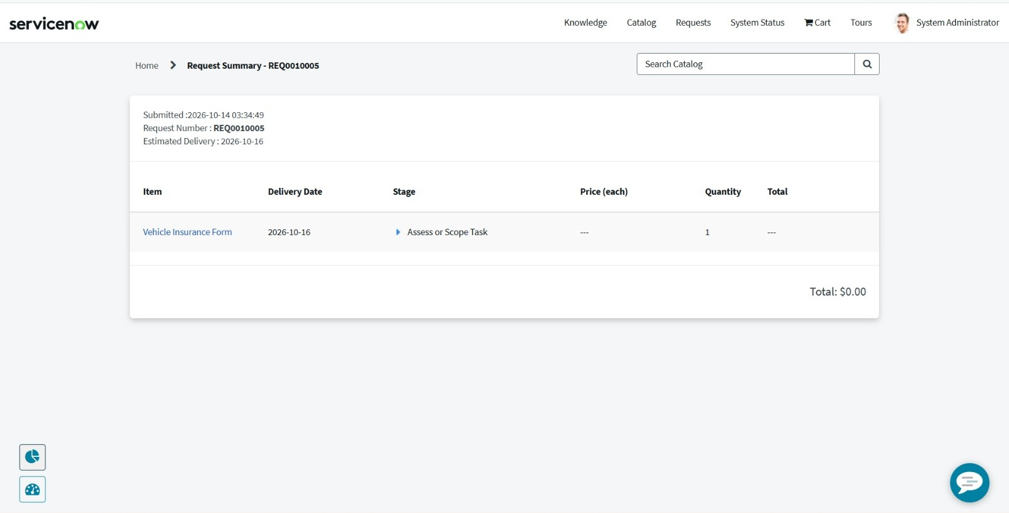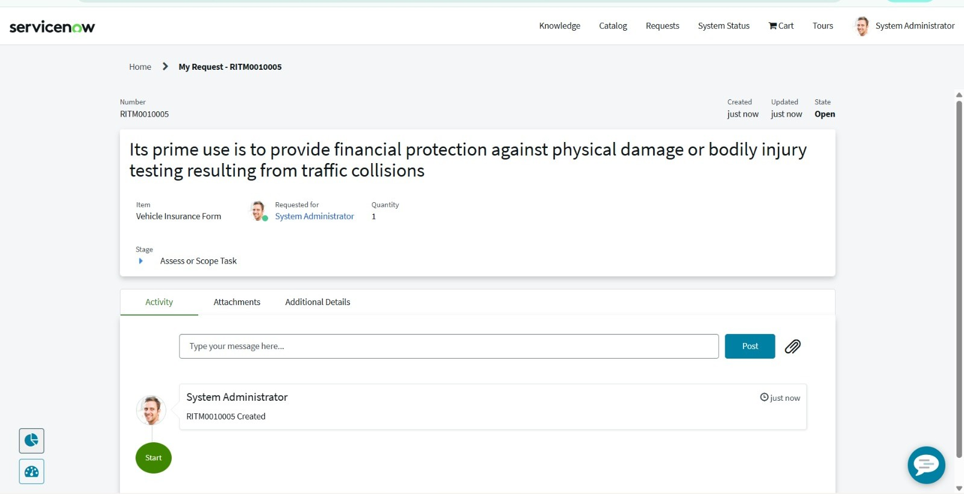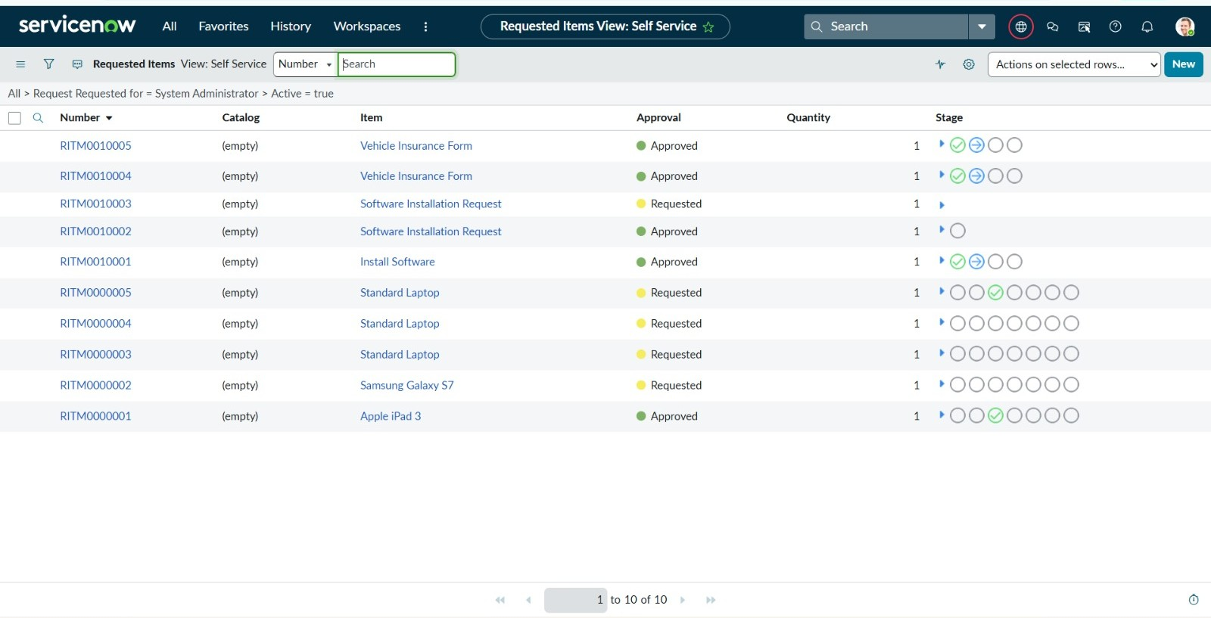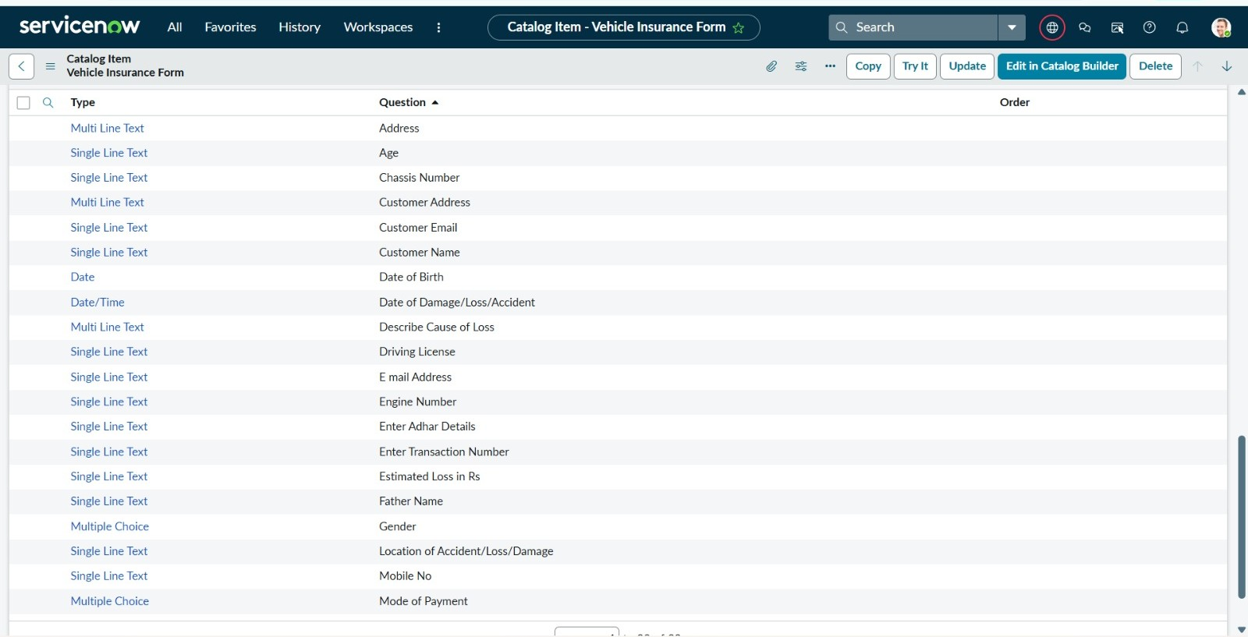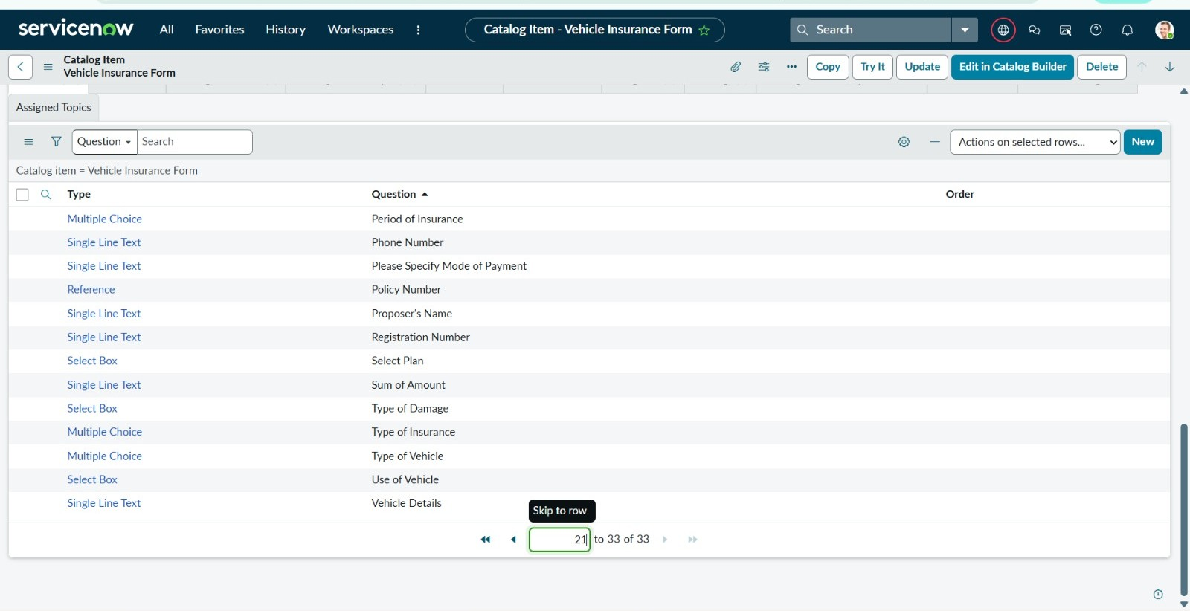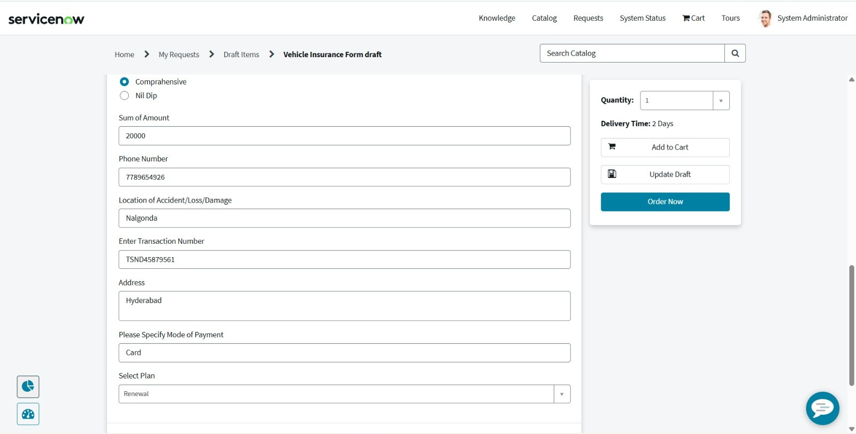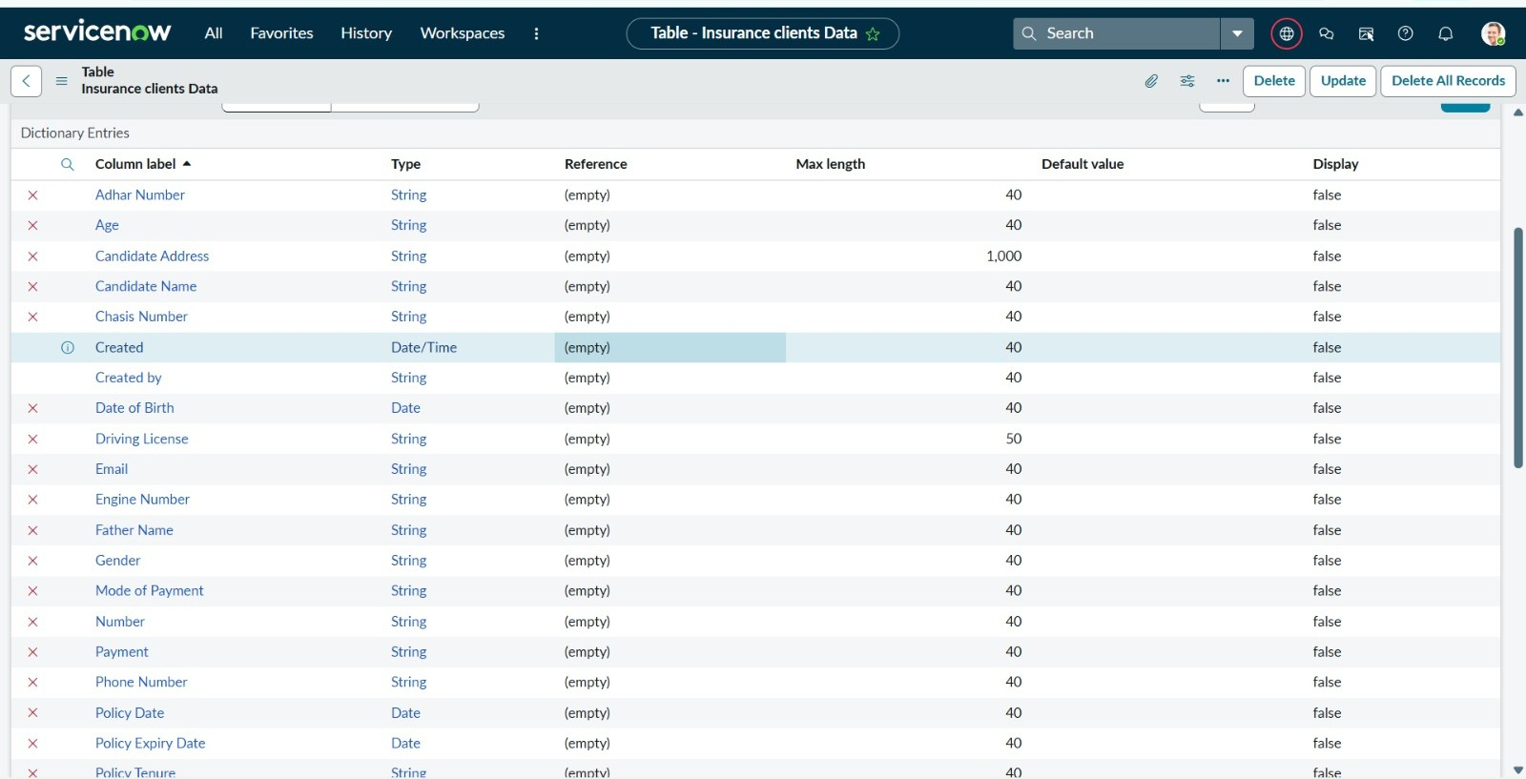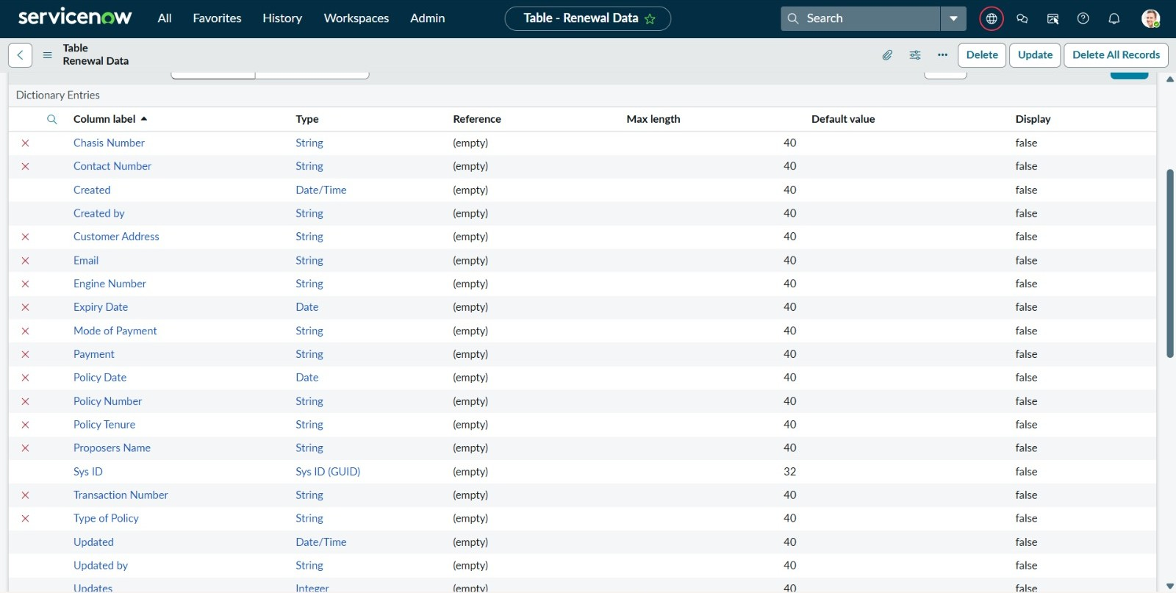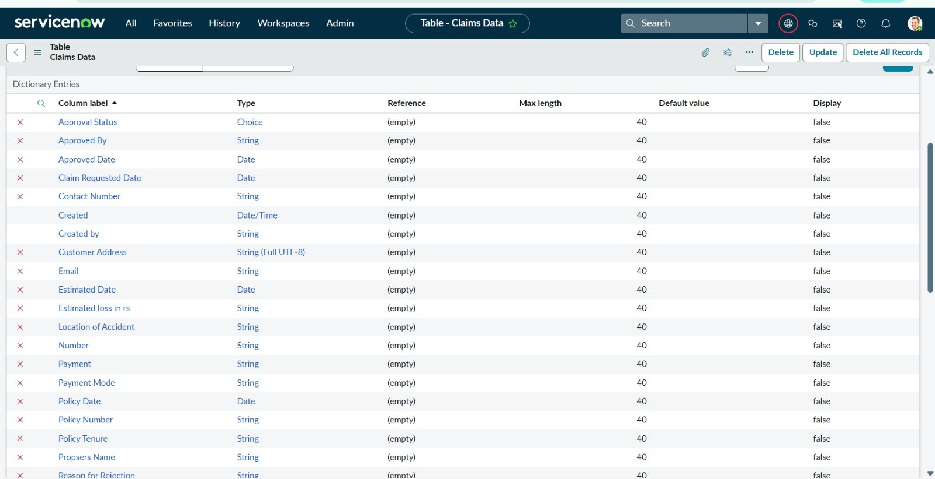
12. Known Issues
- API latency when connecting to external government databases.
- Fraud detection model requires larger training dataset.
13. Future Enhancements
- Mobile app integration via ServiceNow Mobile Studio.
- Advanced fraud detection using deep learning.
- Multi-language chatbot support.
- Blockchain-based claim verification for added transparency.

